School Of Mechanical & Manufacturing Engineering, NUST

Department of Mechanical Engineering

CS-114 - Fundamental of Programing

Lab Task # 08

**Course Instructor:** Dr Khwaja Fahad Iqbal

**Lab Instructor:** Muhammad Affan

**Student Name: ZORAIZ ABBAS**

**CMS ID: 454752**

**DATE:**

**30 NOV 2023**

Fundamental of Programing

**TASK 1:**

Write a c++ program to calculate the average of numbers of array.

**Code:**

#include<bits/stdc++.h>

using namespace std;

int main(){

int n;

double sum=0,average;

cout<<"enter the size of array : "<<endl;

cin>>n;

int arr[n];

cout<<"Enter the numbers in form of array: "<<endl;

for(int i=0;i<n;i++){

cin>>arr[i];

sum+=arr[i];

}

average= sum/n;

cout<<"the average of numbers is: "<<average;

return 0;

}

**Result:**

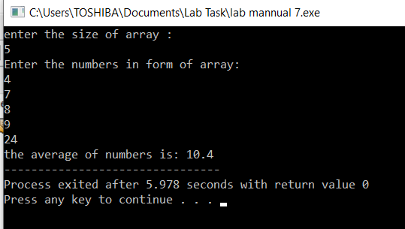

**Task 2:**

Implement bubble sort on an array of 5 integers.

**Code:**

#include<bits/stdc++.h>

using namespace std;

int main(){

int arr[5],temp=0;

cout<<"Enter the 5 numbers in array method: "<<endl;

for(int i=0;i<5;i++){

cin>>arr[i];

}

cout<<"Your entered array is: ";

for(int a=0;a<5;a++){

cout<<arr[a]<<" ";

}

cout<<endl;

for(int j=0;j<5;j++){

for(int k=0;k<4;k++){

if(arr[k]>arr[k+1]){

temp=arr[k];

arr[k]=arr[k+1];

arr[k+1]=temp;

}

}

}

cout<<"The bubble sorted array is: ";

for(int z=0;z<5;z++){

cout<<arr[z]<<" ";

}

return 0;

}

**Result:**

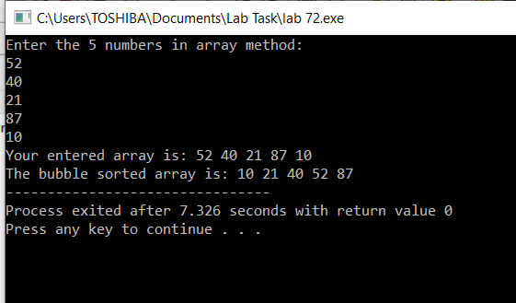

**Task 3:**

Implement selection sort on an array of 5 integers.

**Code:**

#include<bits/stdc++.h>

using namespace std ;

int main(){

int temp=0,arr[5];

cout<<"entet the 5 numbers in array form: "<<endl;

for(int i=0;i<5;i++){

cin>>arr[i];

}

cout<<"entered array is: ";

for(int j=0;j<5;j++){

cout<<arr[j]<<" ";

}

cout<<endl;

for(int k=0;k<4;k++){

int n=k;

for(int x=k+1;x<5;x++){

if(arr[x]<arr[n]){

n=x;

}

}

temp=arr[k];

arr[k]=arr[n];

arr[n]=temp; }

cout<<" The sorted array is: ";

for(int y=0;y<5;y++){

cout<<arr[y]<<" ";

}

return 0;

}

**Result:**

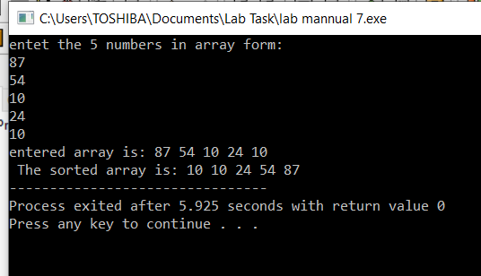

**The end**